**How The System Works**

**Database**

The database ‘clinicdb’ contains Login, Staff_Signup, appointments and users table. The Login table houses all users including the clients, staff and admin. This table is what the login.php module uses to identify between user types and display content accordingly. Staff_signup table houses the staff details added by the admin. Appointments table contains all the user appointments. These are displayed to each user accordingly. While the users table contains detailed info on all the clients that have signed up.

**How Buttons switch on Log In and Log Out**

The buttons are actually a PHP module called ‘buttons.php’. Login and Sign up open up their respective modals as shown below, but once you’ve logged in (either staff or as a client), the buttons display a dropdown with a Log out button and a client and staff specific button. This is accomplished using sessions in PHP, we save the active and name variables in a session and then used an if statement to check if session is logged and active is = 1. Assuming those conditions are true, we then check if user_type is either staff or client. For the former, we display a Log Out and Your Appointments button, and for the latter we display a Log Out and View All Appointments button.

**Sign Up**

Once you click on the sign up button a modal windows opens up where a client enters his/her details and clicks on register, which takes them to register.php module. These details are then stored in a database. The password is hashed using BCRYPT for security reasons and we use a md5 hash to store a hash value corresponding to that user and we also keep the active 0 by default. We then store a message in a session variable and display it to the user once they register. An email is sent using PHPMailer to the user with a link to their email.

Clicking on the link opens up the verify.php module. The link sent contains a user’s email and the hash value, we retrieve that value and compare it against the records in the database. A MySQL query checks if the subsequent email and hash are in the database, and their active is set to 0, if they are, we update that record and set the active to 1. Active 1 signifies that the user has verified and activated their account.

Register.php stores user details in two tables, users and login. The former contains just user details while the latter also contains their user type to identify the user as staff, client or admin.

In the event the query returns nothing, the user is taken to an error page (error.php).

**Login**

Click on the Log in Button opens up a modal window with a login form. Clicking on the Log In button in the modal open up the login.php module where the entered credentials are checked against the login table in the database. In our system, we allow both users and staff to login through the front-end login modal. Login.php runs 2 queries that check the user type and their email. If the results return nothing, then the user is taken to the error page (error.php) where an appropriate error message is displayed.

But, if the queries return a result. For both staff and clients we fetch that data into an associative array and then run a password verify function against the password to check if the entered password is correct. If the password is correct, we store email, name, user type and active in the session and set logged in session to true. The user is then logged in and check their respective appointments and so on.

The user is taken to the error page if the password verify function run against the password is wrong.

**User & Staff Appointments**

Appointments made by registered users are saved in the appointment table, and their status is not confirmed by default.

Once, either the user or staff are logged in, they can check their appointments. For the users, clicking on the ‘Your Appointments’ button takes them to client.php module. This module first and foremost checks if the user is logged in and then open up, otherwise users are taken to an error page. Once a verified user is logged in, a MySQL query is run against their email. This query checks the appointment table for any past, present or future appointments made by that user. If there are any, they are fetched in an array and displayed in a table format.

Users can cancel any of their appointments if they so desire.

For staff, clicking on ‘View All Appointments’ button takes them to staff.php module where all appointments made by all users are fetched from the database in an array and displayed in a table format. The staff doctors can view all appointments made and confirm the appointments shown to them, or leave them ‘Not Confirmed’. Clicking on the tick, updates the table and sets ‘Not Confirmed’ to ‘Confirmed’.

**Admin**

The admin cannot login through the front-end, admn-login.php modules takes the admin to a admin-specific log in. The entered email and password is checked against the login table where the email and user type is admin. If yes, then the admin page is displayed (The admin page cannot be opened directly, It can only be accessed through the login page). The admin page contains three modules – admin_display.php, admin_staff.php and admin_delete.php. Admin_display.php displays all the users including the staff and users. Admin_staff.php allows the admin to add new staff members in the system using a form in the Registration tab. While, admin_delete.php allows the admin to delete any user (client or staff) to be deleted by clicking on the ‘trash’ icon.

**Contact**

The contact form opens the contact.php module where the user entered queries are validated and sent to the clinic’s admin or support staff using PHPMailer.

**Reset Password**

Reset password works on the base of forgot.php, reset.php and reset_password.php modules. The principle is the same as signup, except once an email is provided a confirmation link is sent and assuming its true, the user is then allowed to change the password of his/her account.

**Home Page:**

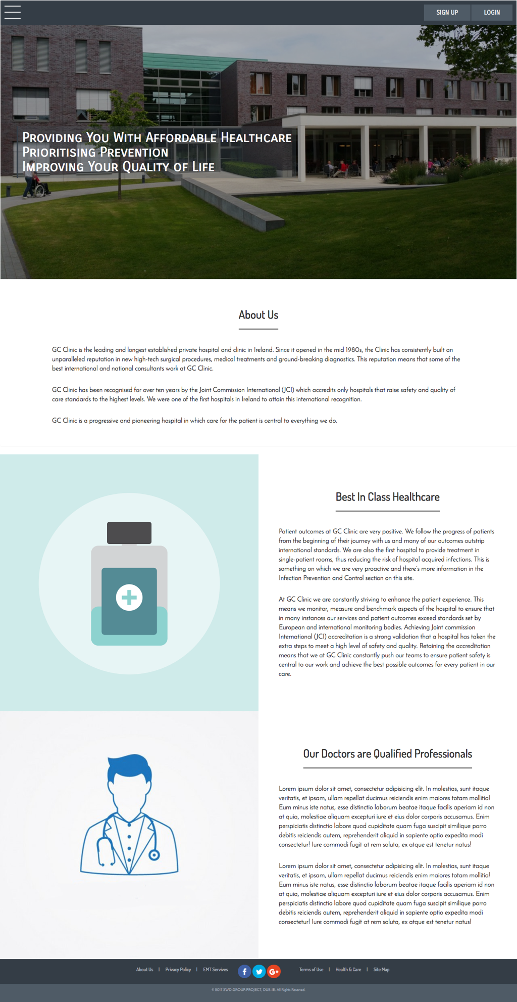

**Services Page:**

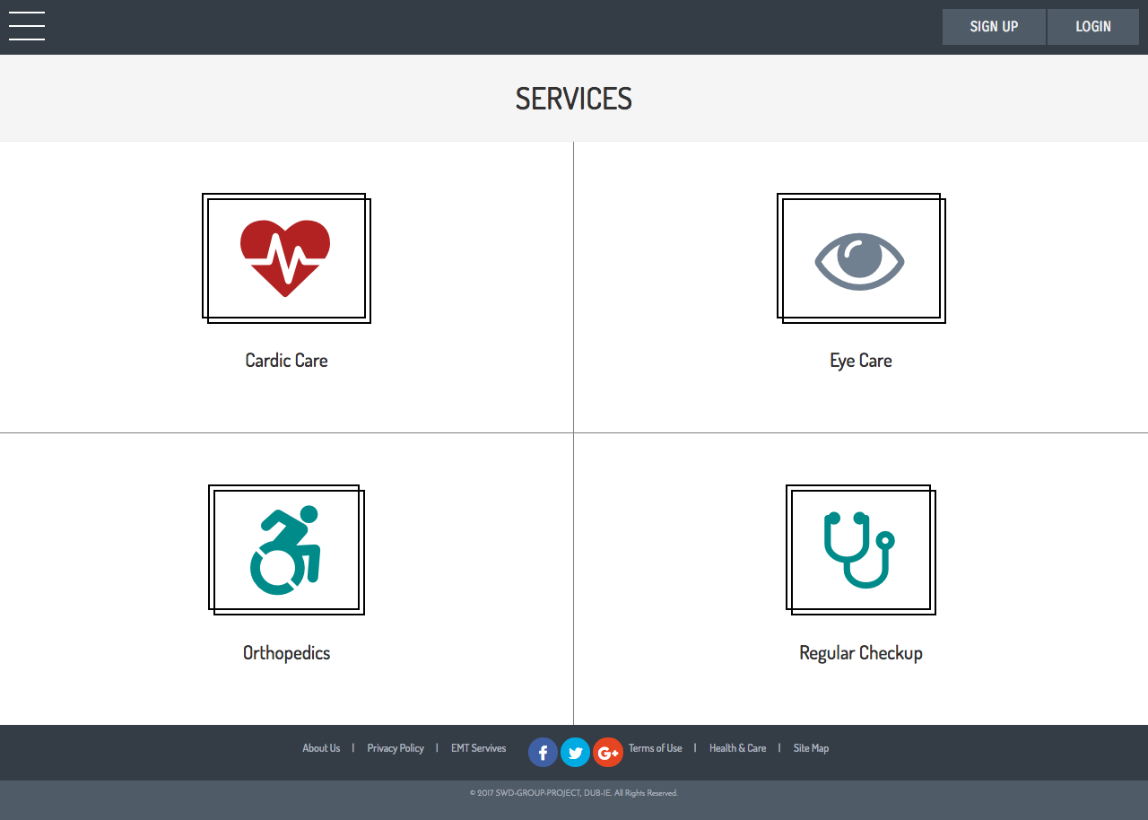

**Resources Page:**

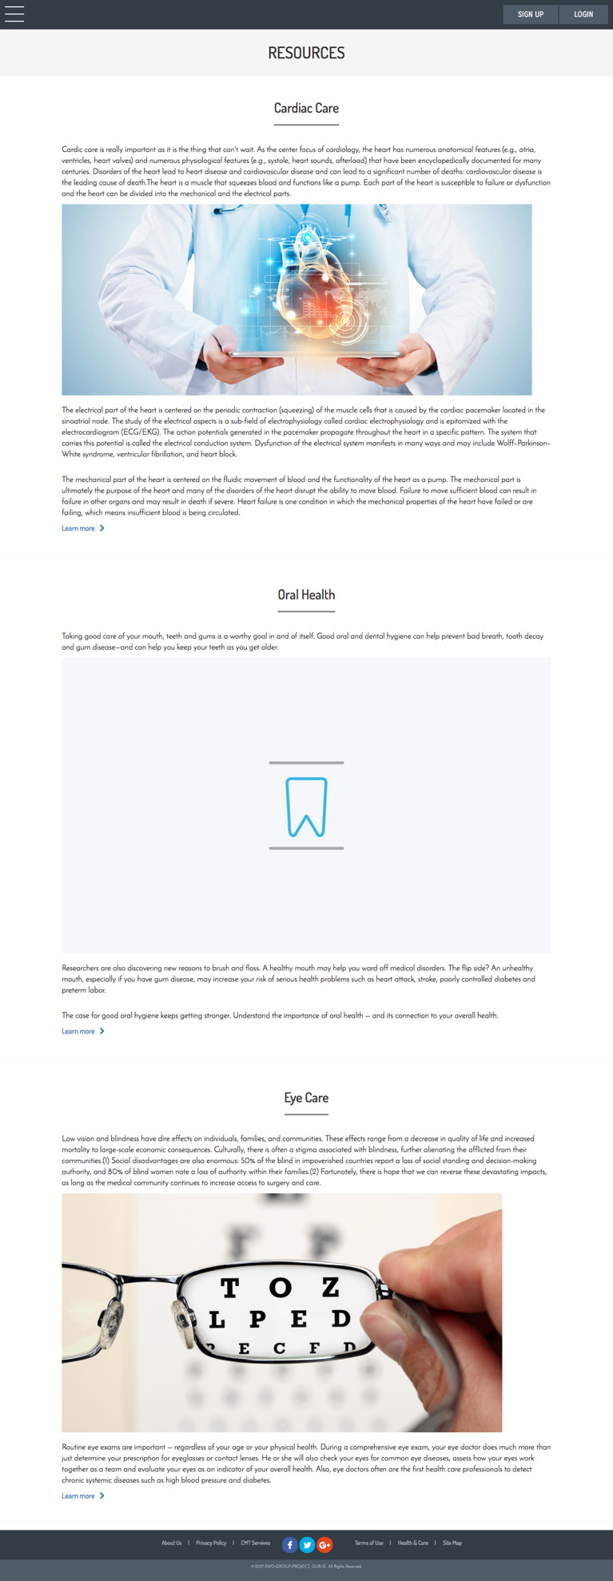

**Consultation Fee Page:**

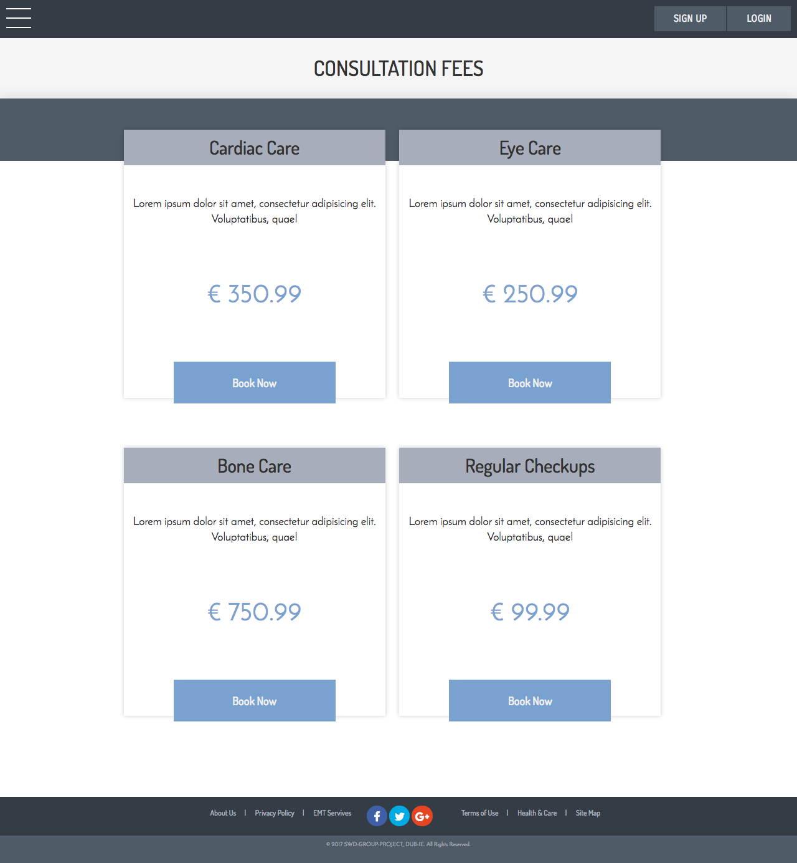

**Appointments Page:**

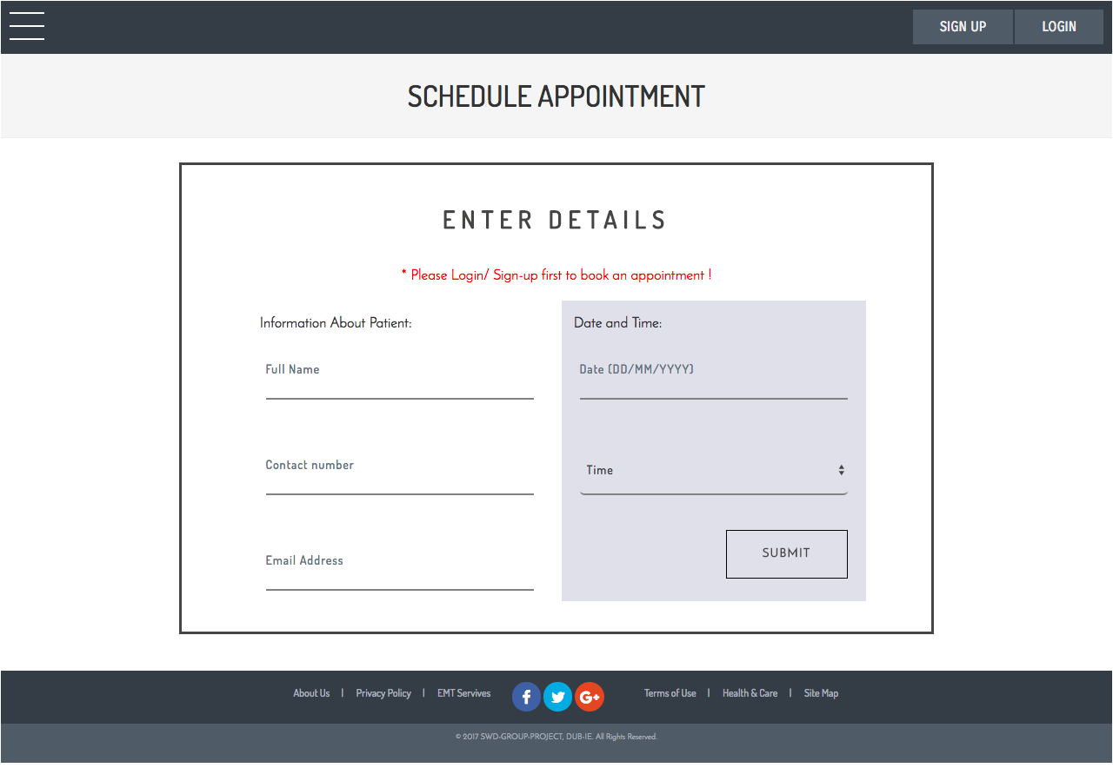

**Contact Us Page:**

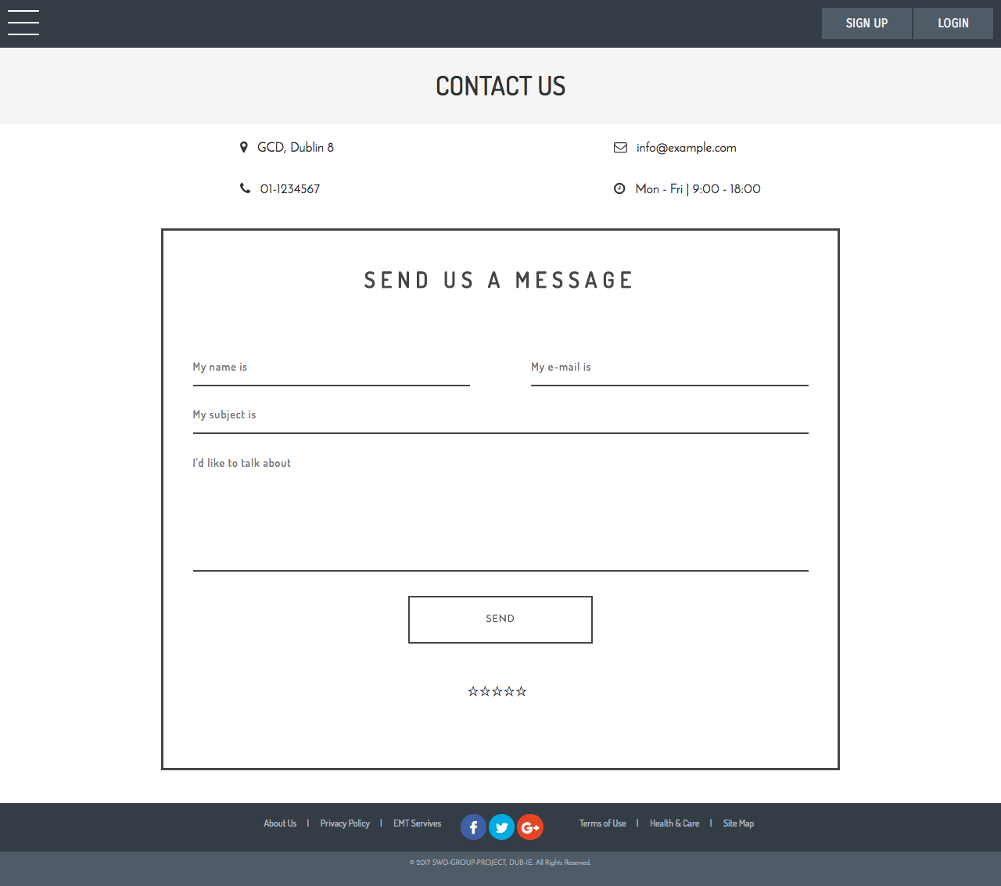

**Admin Page:**

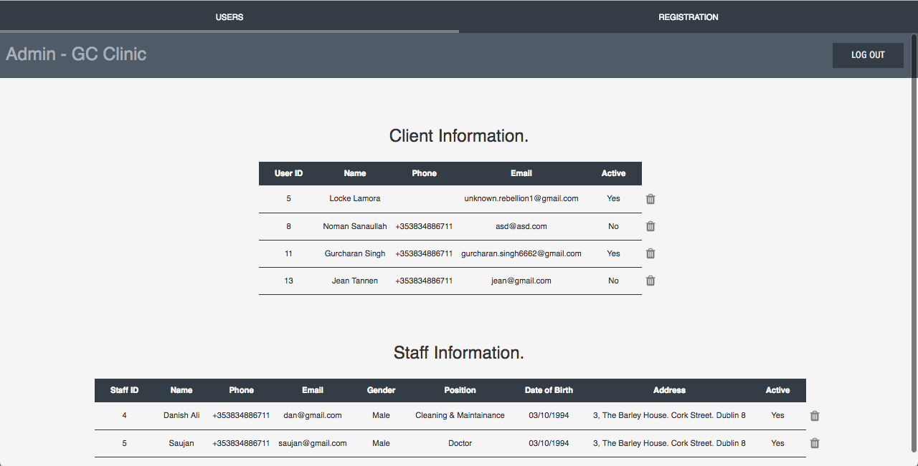

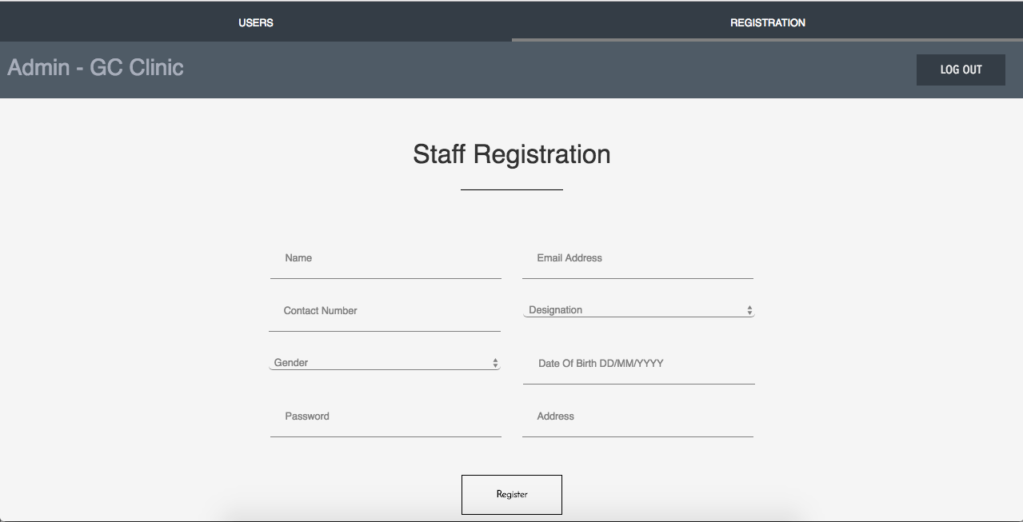

**Client Appointment Page:**

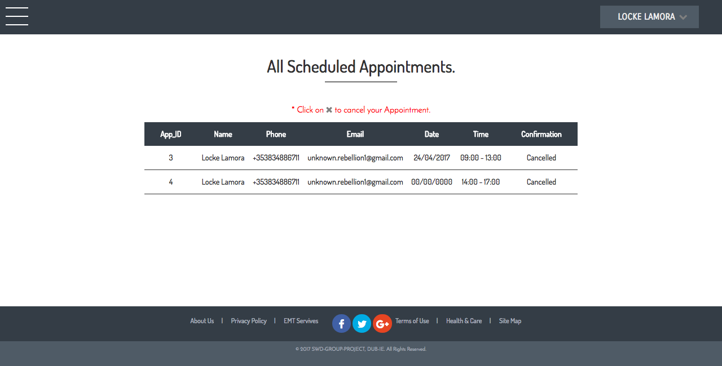

**Staff Appointment Page:**

